**Lab Report: Exploratory Data Analysis on World Population Dataset using PySpark**

**1. Objective**

The objective of this lab is to perform Exploratory Data Analysis (EDA) on a World Population dataset using PySpark. The dataset contains population-related data from various countries, consisting of 234 rows and 17 columns. The analysis includes understanding the structure of the dataset, data types, statistical summaries, visualizations, handling missing values, and removing duplicate records.

**2. Tools & Technologies**

* **Language**: Python
* **Library**: PySpark
* **Environment**: Locally via Docker Image

**3. Column-wise Description**

| **Column Name** | **Description** |
| --- | --- |
| Rank | Position of the country based on population or other metrics |
| CCA3 | ISO 3166-1 alpha-3 country code (3-letter) |
| Country | Name of the country |
| Capital | Capital city of the country |
| Continent | Continent the country belongs to |
| 2022 Population | Population in the year 2022 |
| 2020 Population | Population in the year 2020 |
| 2015 Population | Population in the year 2015 |
| 2010 Population | Population in the year 2010 |
| 2000 Population | Population in the year 2000 |
| 1990 Population | Population in the year 1990 |
| 1980 Population | Population in the year 1980 |
| 1970 Population | Population in the year 1970 |
| Area (km²) | Land area of the country in square kilometers |
| Density (per km²) | Population density (people per square kilometer) |
| Growth Rate | Annual growth rate of population |
| World Population Percentage | Share of the country in the total world population (in %) |

**4. Steps**

**1: Importing Data:**

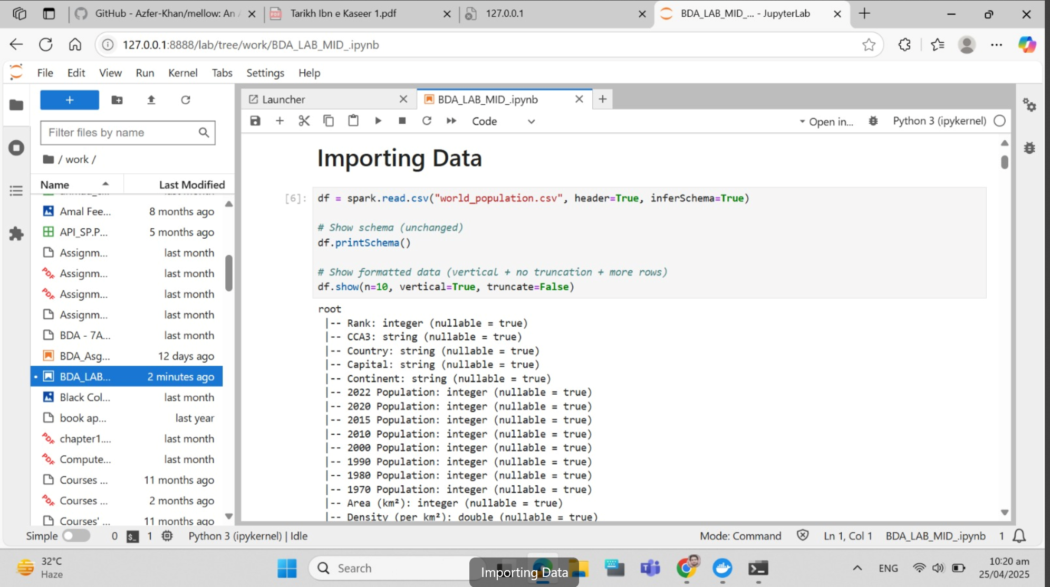

**2: Data Preview:**

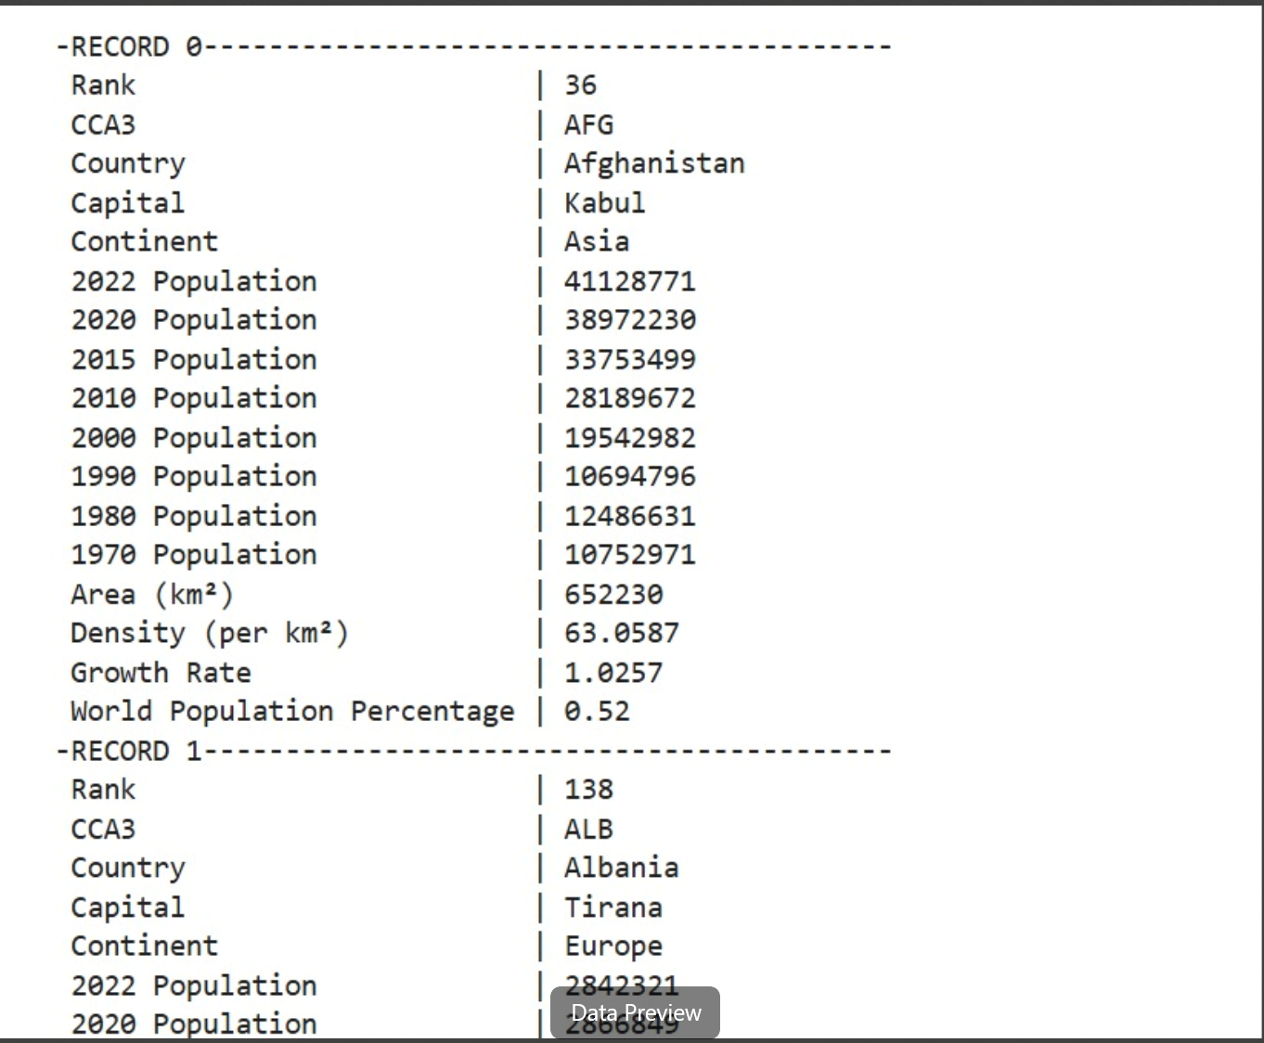

**3: Dimensions and Columns:**

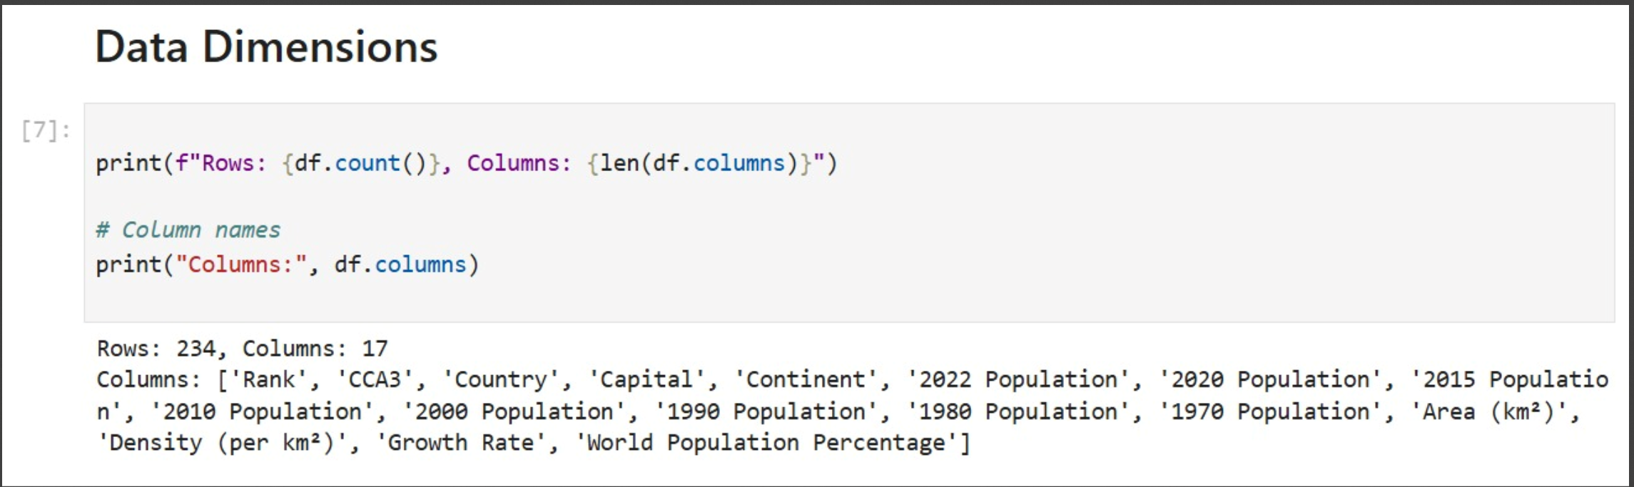

**4: Data Types:**

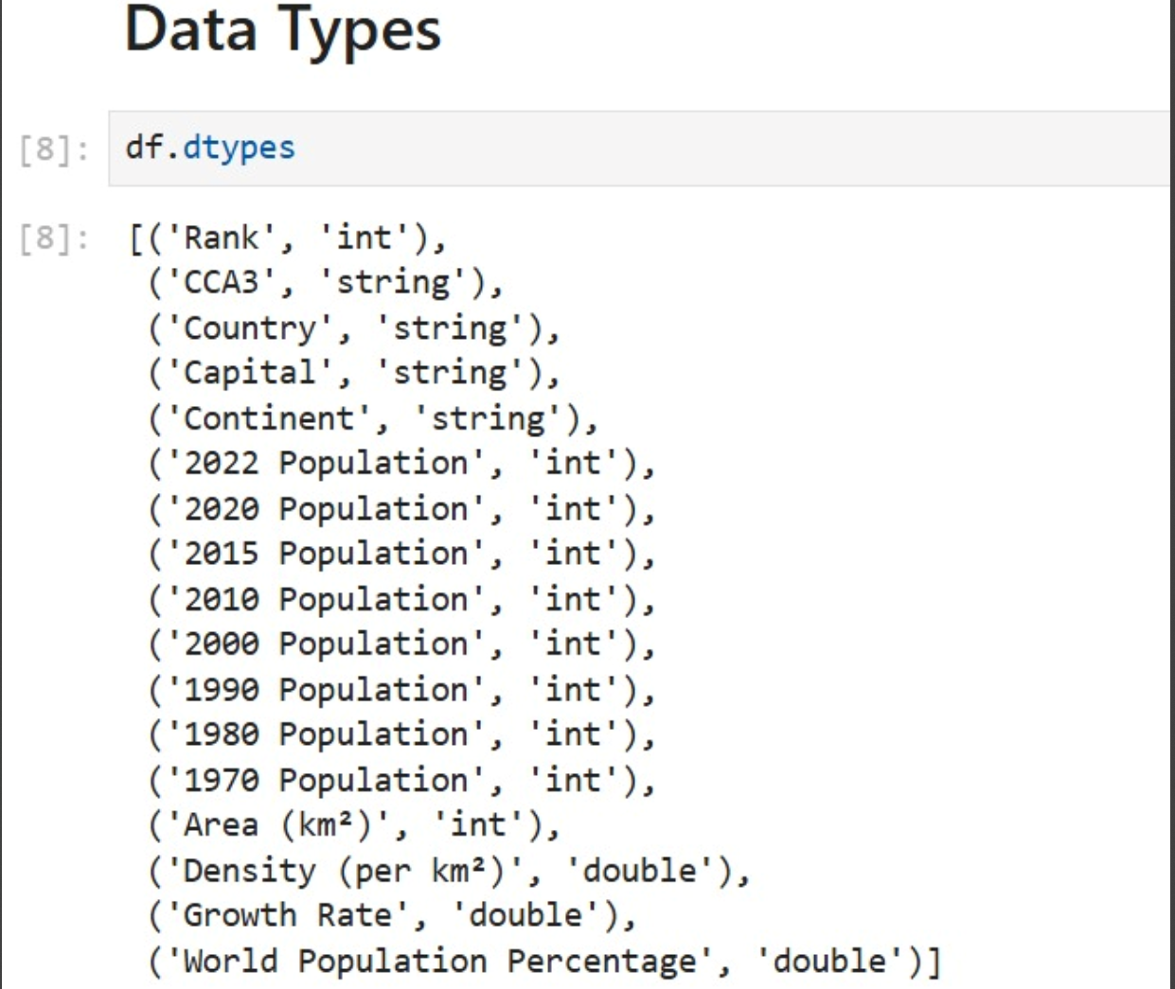

**5: Describing Data:**

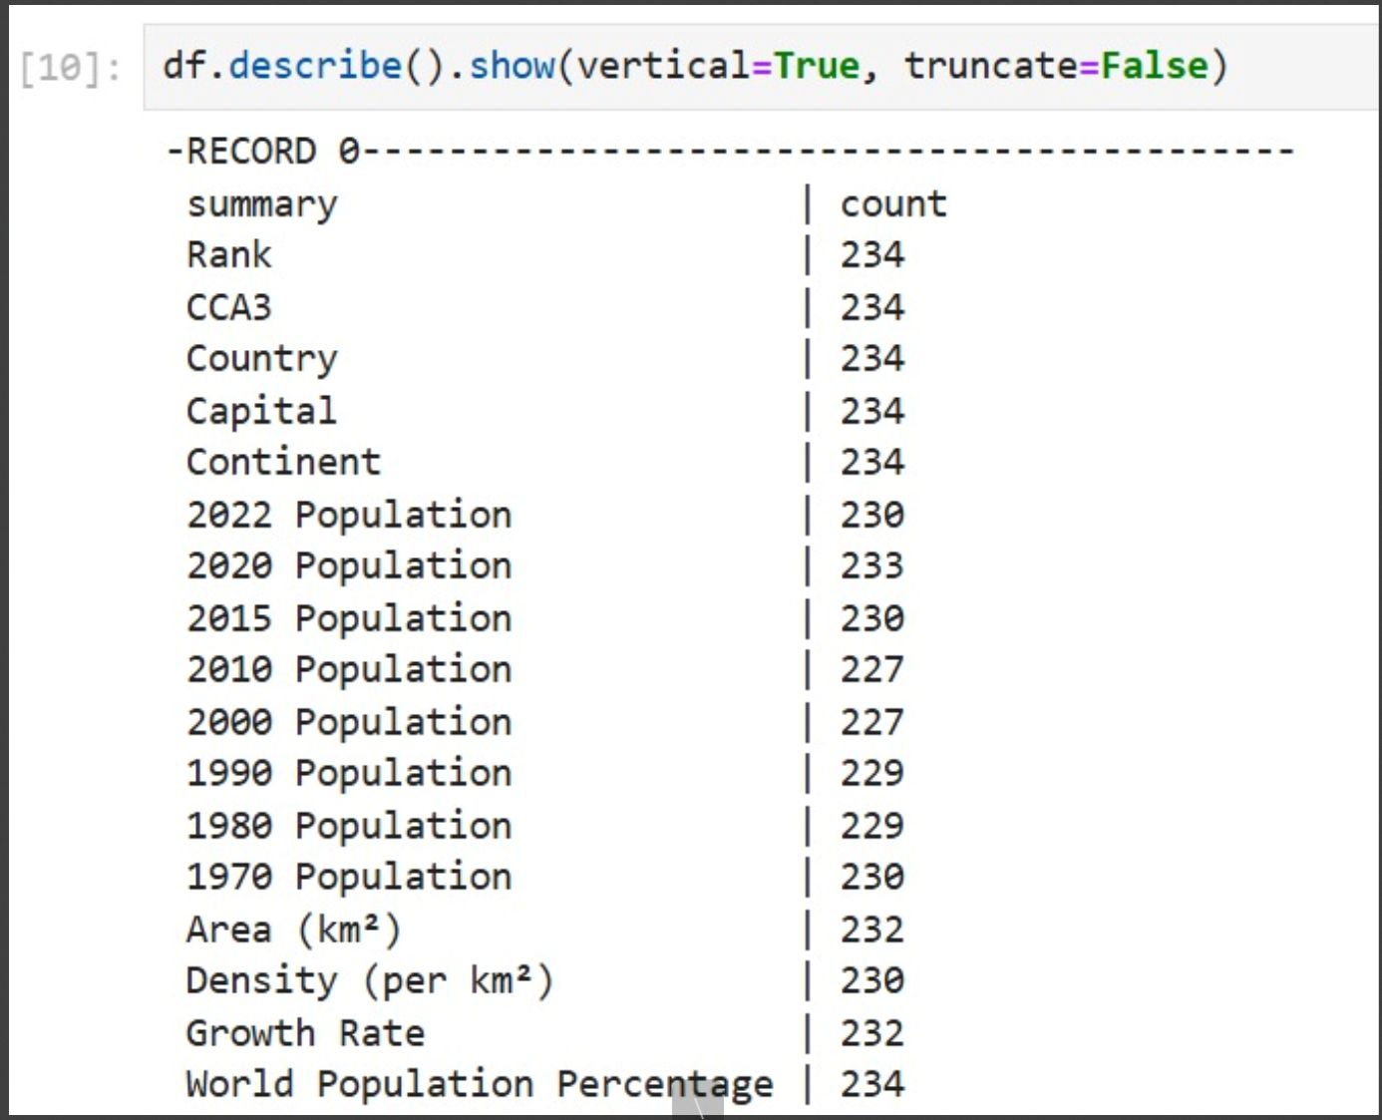

**6: Mean Standard Deviation:**

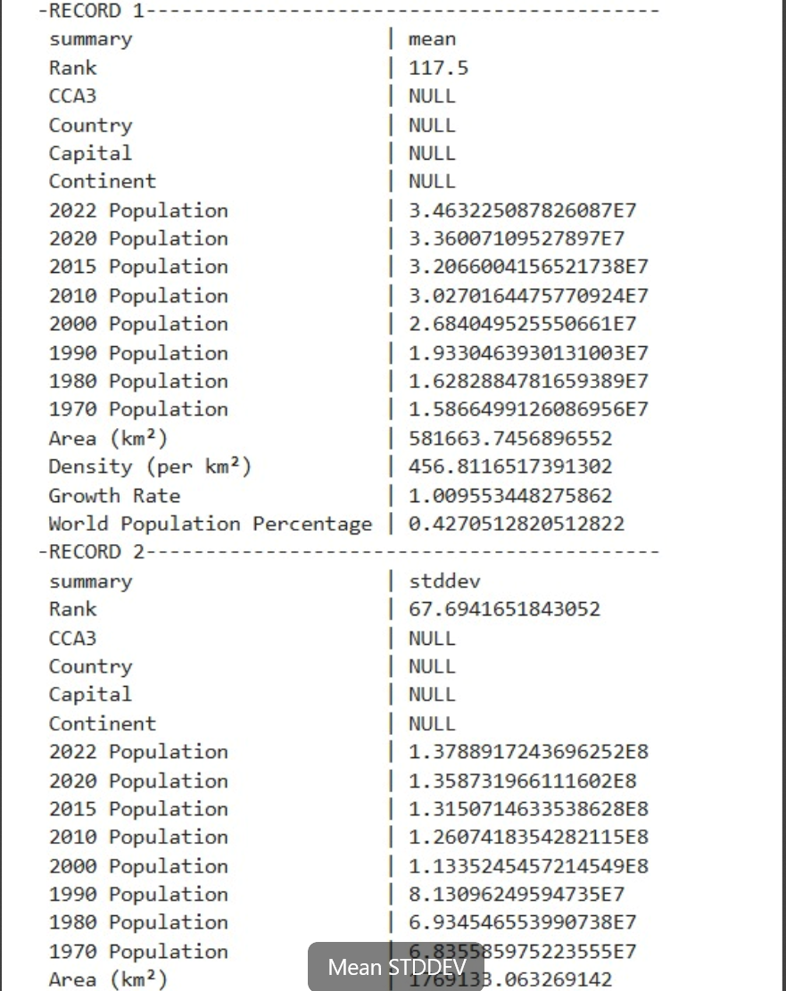

**7: Min Max :**

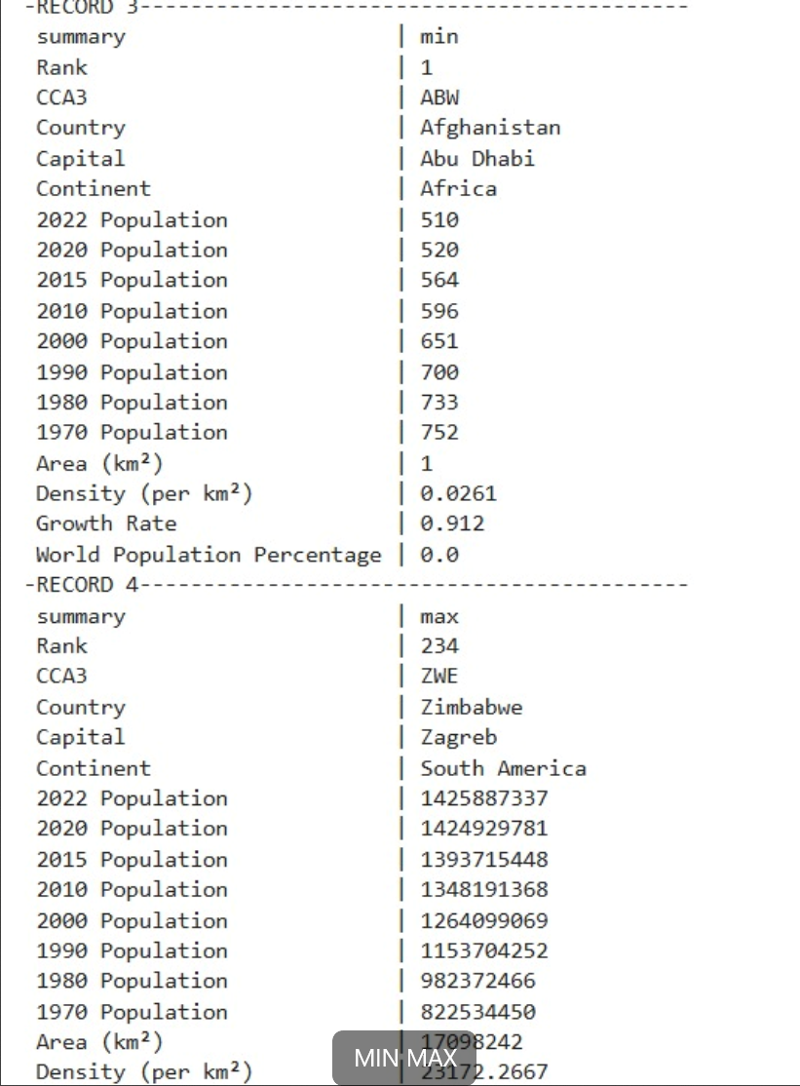

**8: Null Values:**

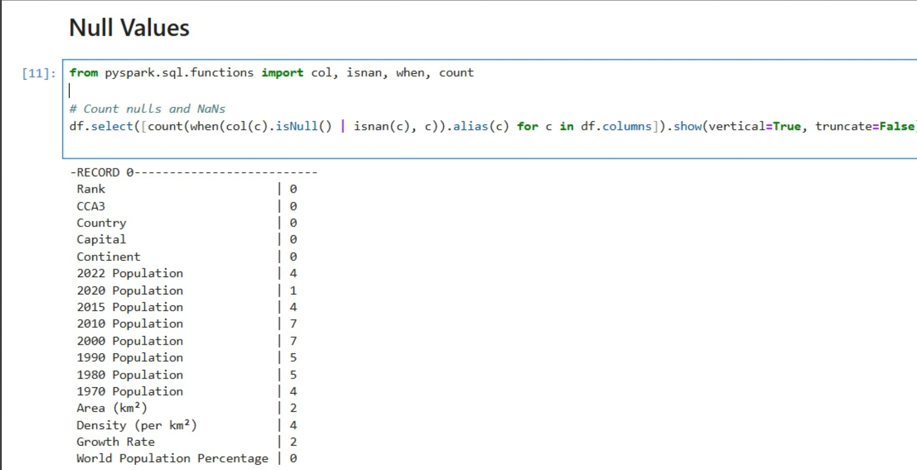

**9: Creating Histograms:**

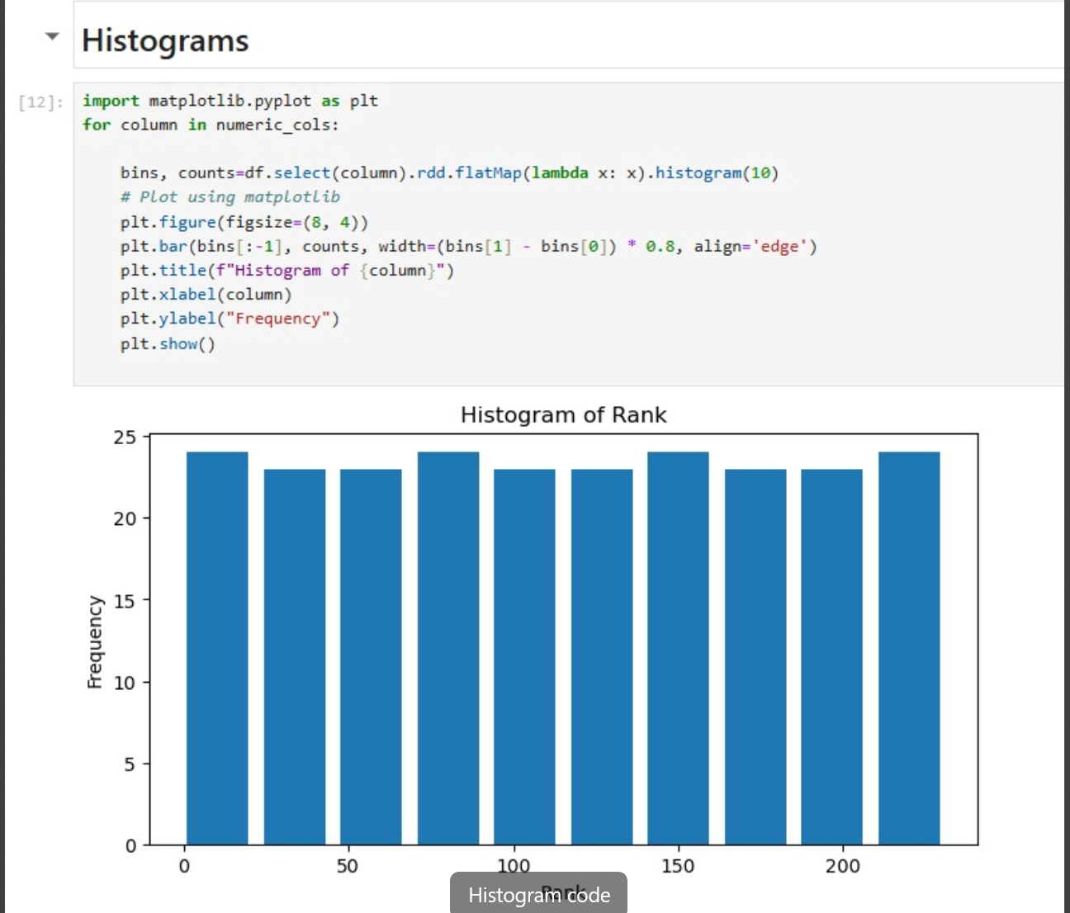

**10: Data Imputation :**

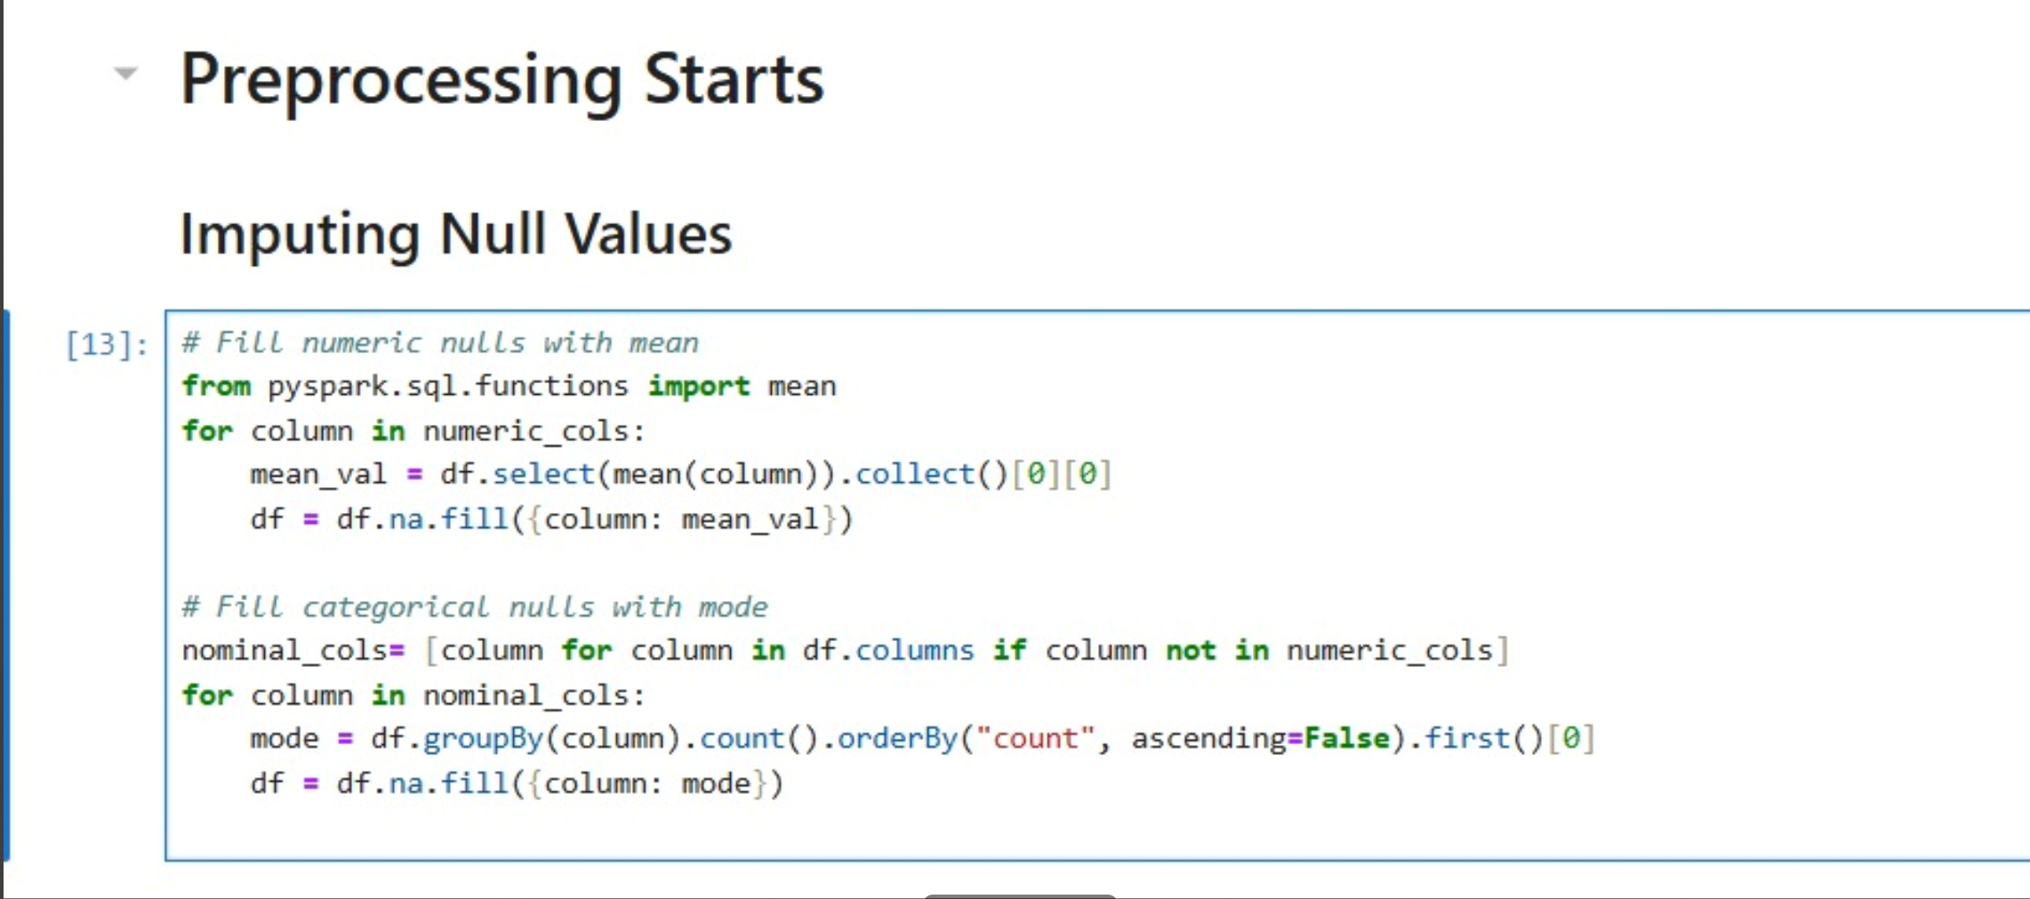

**11: All Null Values Removed:**

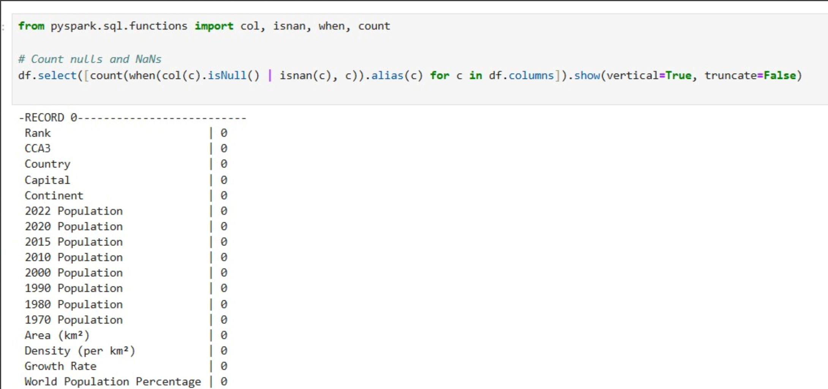

**12: Continent based population comparison from year 1970 to year 2022:**

